USECASE DIAGRAM SiPeMa
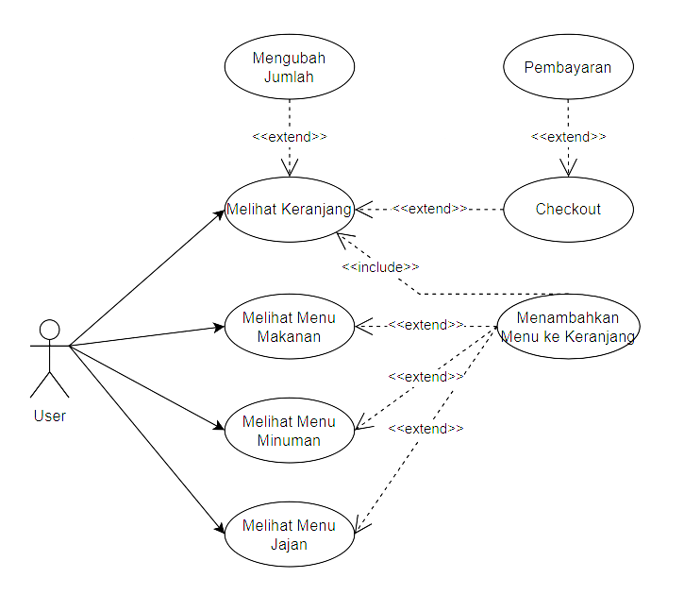

A use case diagram shows the interaction between users and the system, as well as the main functionalities:
- Viewing Food Menu: Users can choose a food category to see the available menu list.
- Viewing Drink Menu: Users can choose a drink category to see the drink menu list.
- Viewing Snack Menu: Users can choose a snack category to see the snack menu list.
- Adding Items to Cart: Users can choose food, drinks, or snacks to add to the shopping cart.
- Viewing Shopping Cart: Users can see the items in their cart.
- Changing Quantity: Users can change the quantity.
- Checkout: Users can complete the order transaction.
- Payment: Users can make a payment.

ENTITY RELATIONSHIP DIAGRAM (ERD)
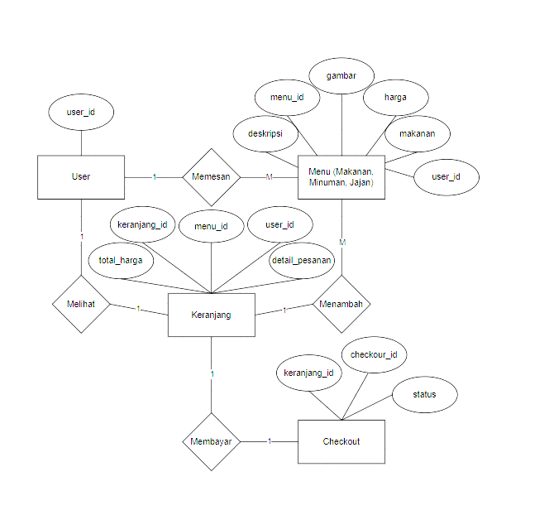

The ERD above illustrates the relationships between users, menus, shopping carts, and the checkout process in a food, drink, and snack ordering system. Each user has a cart that stores the menu items they order, and that cart can be checked out to complete the transaction. The relationships between entities have been designed to cover the ordering flow with relevant attributes.

